Appendix A. Python installation instructions
Please ignore grammar errors and typos. What you see is a raw manuscript; it has not been copyedited.
The projects in the book are technology-agnostic and the example solutions are mostly about the process, not the specifics of Python, which is my technology of choice. However, if you are a Python user like me, you might want to recreate my results on your machine and take my example solution as a starting point. To be able to do this, this appendix explains how to install Python and set it up in a way that mimics the setup I used for the example solutions.
Usually, the Python libraries required for a project are listed in the accompanying Jupyter notebooks and can be inferred from the import statements. That is, if the code in a solution imports pandas, you will need to have installed the pandas library. However, to recreate my examples exactly, you need to have the same version of each library, since functionality changes across versions. There are many ways to ensure your Python environment is set up the same as mine, but generally this is done through the use of virtual environments.

Note
it is not necessary to have exactly the same setup as me to recreate the solutions in the book. You can likely use a newer Python version and newer versions of libraries like pandas and get the same results. However, the virtual environments are explicitly “pinned” to older versions of both Python and the necessary libraries to ensure compatibility with each other. An example is the recordlinkage library used in chapter 3, which at time of writing is incompatible with pandas version 2.0.
Virtual environments let you have multiple combinations of Python libraries, even different versions of Python, on the same machine, usually one per project. I recommend creating a virtual environment in which you can run the accompanying code examples and ensure your libraries have the same versions as mine. Again, there are many ways to setup virtual environments. You may already have your favorite way to do this, or you may have never encountered virtual environments before. In this book, I use the poetry library and the following sections include instructions to recreate my environment.

A.1 Step by step
To create a virtual environment to recreate the one I used when creating the solutions, follow these steps.

A.1.1 Install Python
Specifically, the projects in the book use Python 3.11 but that is only a requirement if you want to recreate the example solutions exactly. If you have a different version of Python already installed but want to recreate my environment, you can install Python 3.11 anyway as it will be separate from other Python installations.
You can either install Python directly from Python.org: https://www.python.org/downloads/ or through a bundled version, like Anaconda (https://www.anaconda.com/download). You can also install Python through a minimal version of Anaconda, such as miniconda (https://docs.conda.io/en/latest/miniconda.html) or miniforge (https://github.com/conda-forge/miniforge).
I personally use miniforge, but as long as the end result is that you have Python 3.11 installed on your machine, it doesn't matter where you got it from.

A.1.2 Install poetry
Poetry is the package and dependency management system I chose to manage my virtual environments. You can install it within your Python installation using whichever in-built package manager you have, usually pip or conda. An example command, which should be run in a terminal or command prompt, is as follows:
pip install poetry
copy
More information about poetry is available here: https://python-poetry.org/.

Note
If you use a different method for managing virtual environments, such as virtualenv, I have also included a requirements.txt file, which contains the same information as the poetry files, but is the format required for these other tools. This will still require that you use Python 3.11.

A.1.3 Create your virtual environment
In the materials for the book I have supplied two files, poetry.lock and pyproject.toml, both of which you need to recreate my virtual environment with the same versions of all necessary libraries. At the time of writing, you simply need to have those two files in the root folder where you have downloaded the code for the book.
First, navigate to your code folder where these files reside and run the following command to ensure poetry uses Python 3.11 regardless of what other versions exist on your machine. An example in a command prompt is shown in figure A.1.
poetry env use /path/to/your/python3.11/python.exe
copy

Figure A.1 command to tell poetry where Python 3.11 is installed
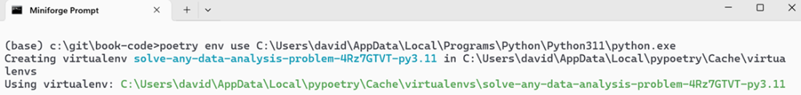

Neutral - Challenging to setup. Needs to examples of command lines for
- Windows
- Mac
- Linux
Next, run the following command to create your virtual environment. The correct versions of the necessary libraries will be installed. Figure A.2 shows what the output might look like.
poetry install
copy

Figure A.2 installing the poetry environment and associated libraries
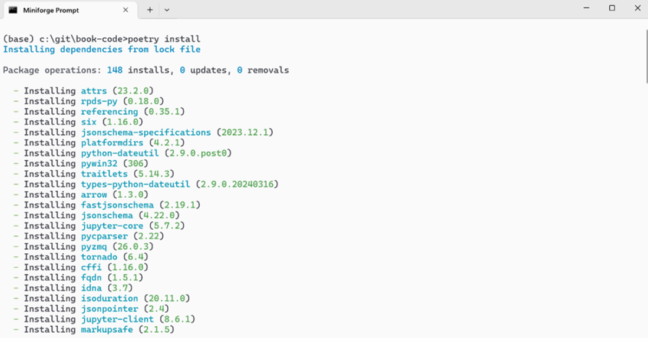

Up
At this point, you have a virtual environment which is set up the same as mine. You can activate it by running the following command.
poetry shell
copy
This will activate the environment, and any subsequent Python commands will run in this environment instead of the base one. From here, you can launch Jupyter using the following command.
jupyter notebook
copy
This will launch Jupyter and you can interact with the code using the correct versions of Python and its libraries. Figure A.3 shows the final poetry commands before launching Jupyter.

Figure A.3 launching Jupyter from the poetry environment
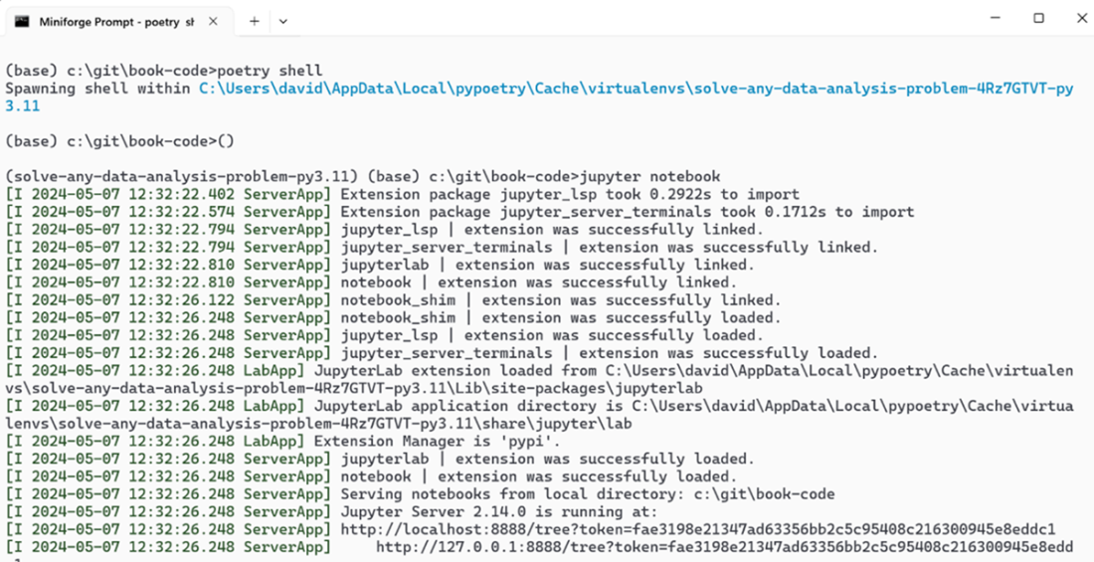
Up
Any comments on section A.1 Step by step?
Up

What did you think of this chapter?

hide feedback

1
How many stars would you give this chapter?

4

2
What is your overall impression of this chapter?

Fairly simple to follow, but needs sample command lines for:
- Windows
- Mac
- Linux

